Quiz

Python:

1. Which of the following variable names is invalid in Python?
- A) _variable
- B) variable123
- C) 123variable
- D) variable_name

Answer: C) 123variable
2. What will the following code snippet return?
my_list = [1, 2, 3, 4, 5]
print(my_list[-2])
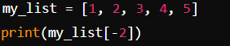
- A) 1
- B) 4
- C) 3
- D) 5

Answer: B) 4
3. Which list comprehension correctly generates a list of squares from 1 to 10?
- A) [x * x for x in range(1, 11)]
- B) [x ** 2 for x in range(11)]
- C) [x ^ 2 for x in range(1, 10)]
- D) [x^2 for x in range(1, 11)]
Answer: A)
4. What will be the output of the following code?

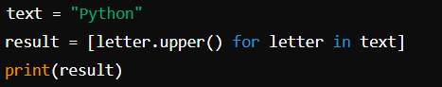

A) ['python']
B) ['P', 'Y', 'T', 'H', 'O', 'N']
C) ['PYTHON']
D) 'PYTHON'

Answer: B) ['P', 'Y', 'T', 'H', 'O', 'N']

5. What will be the output of the following code?
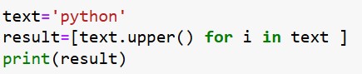

A) ['PYTHON']
B) ['P', 'Y', 'T', 'H', 'O', 'N']
C) ['PYTHON', 'PYTHON', 'PYTHON', 'PYTHON', 'PYTHON', 'PYTHON']
D) 'PYTHON'

Answer C)

6. Which of the following statements will correctly concatenate two lists a and b in Python?
- A) a + b
- B) a.append(b)
- C) a.concat(b)

Answer: A) a + b

7. What will be the output of the following code?
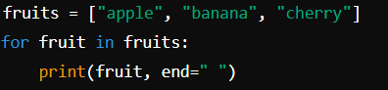

A) apple, banana, cherry
B) apple banana cherry
C) applebanana cherry
D) 'apple', 'banana', 'cherry'

Answer: B) apple banana cherry

Coding

8. Write a Python program to convert a given tuple of positive integers into an integer.
Original tuple:(1, 2, 3)
Convert the said tuple of positive integers into an integer:123

Answer
original_tuple = (1, 2, 3)
new=int(str(original_tuple[0])+str(original_tuple[1])+str(original_tuple[2]))
print('The integer is',new)

original_tuple =(1,2,3)
new=int("".join(map(str, original_tuple)))
print(new)

9. Write a Python program to compute the sum of all the elements of each tuple stored inside a list of tuples.
Original list of tuples:
[(1, 2), (2, 3), (3, 4)]
Sum of all the elements of each tuple stored inside the said list of tuples:
[3, 5, 7]

Answer:
listoftuple=[(1, 2), (2, 3), (3, 4)]
new = [sum(i) for i in listoftuple]
print(new)

def conca(tuple):
new =(tuple[0])+(tuple[1])
number=int(new)
return number
list=[conca(1,2) , conca(2,3) , conca(3,4) ]
print(list)

